**SMO 2014 Senior Section Questions**

**Multiple Choice**

**June 3rd**

**1**

If $\alpha$ and $\beta$ are the roots of the equation $3x^2+x-1=0$, where $\alpha>\beta$, find the value of 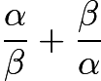.  
  


**2**

Find the value of 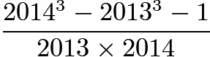.  
  
$ \textbf{(A) }3\qquad\textbf{(B) }5\qquad\textbf{(C) }7\qquad\textbf{(D) }9\qquad\textbf{(E) }11 $

**3**

Find the value of 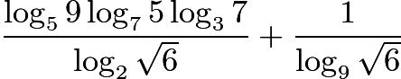  
  
$ \textbf{(A) }2\qquad\textbf{(B) }3\qquad\textbf{(C) }4\qquad\textbf{(D) }6\qquad\textbf{(E) }7 $

**4**

Find the smallest number among the following numbers:  
  
$ \textbf{(A) }\sqrt{55}-\sqrt{52}\qquad\textbf{(B) }\sqrt{56}-\sqrt{53}\qquad\textbf{(C) }\sqrt{77}-\sqrt{74}\qquad\textbf{(D) }\sqrt{88}-\sqrt{85}\qquad\textbf{(E) }\sqrt{70}-\sqrt{67} $ $ \textbf{(A) }\sqrt{55}-\sqrt{52}\qquad\textbf{(B) }\sqrt{56}-\sqrt{53}\qquad\textbf{(C) }\sqrt{77}-\sqrt{74}\qquad\textbf{(D) }\sqrt{88}-\sqrt{85}\qquad\textbf{(E) }\sqrt{70}-\sqrt{67} $

**5**

Find the largest number among the following numbers:  
  
$ \textbf{(A) }30^{30}\qquad\textbf{(B) }50^{10}\qquad\textbf{(C) }40^{20}\qquad\textbf{(D) }45^{15}\qquad\textbf{(E) }5^{60}$

**6**

Given that 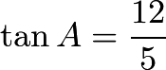, 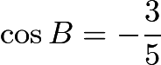 and that $A$ and $B$ are in the same quadrant, find the value of $\cos (A-B)$.  
  


**7**

Find the largest number among the following numbers:  
  
$ \textbf{(A) }\tan47^{\circ}+\cos47^{\circ}\qquad\textbf{(B) }\cot 47^{\circ}+\sqrt{2}\sin 47^{\circ}\qquad\textbf{(C) }\sqrt{2}\cos47^{\circ}+\sin47^{\circ}\qquad\textbf{(D) }\tan47^{\circ}+\cot47^{\circ}\qquad\textbf{(E) }\cos47^{\circ}+\sqrt{2}\sin47^{\circ} $$ \textbf{(A) }\tan47^{\circ}+\cos47^{\circ}\qquad\textbf{(B) }\cot 47^{\circ}+\sqrt{2}\sin 47^{\circ}\qquad\textbf{(C) }\sqrt{2}\cos47^{\circ}+\sin47^{\circ}\qquad\textbf{(D) }\tan47^{\circ}+\cot47^{\circ}\qquad\textbf{(E) }\cos47^{\circ}+\sqrt{2}\sin47^{\circ} $

**8**

$\triangle ABC$ is a triangle and $D,E,F$ are points on $BC$, $CA$, $AB$ respectively. It is given that $BF=BD$, $CD=CE$ and $\angle BAC=48^{\circ}$. Find the angle $\angle EDF$  
  
$ \textbf{(A) }64^{\circ}\qquad\textbf{(B) }66^{\circ}\qquad\textbf{(C) }68^{\circ}\qquad\textbf{(D) }70^{\circ}\qquad\textbf{(E) }72^{\circ} $

**9**

Find the number of real numbers which satisfy the equation $x|x-1|-4|x|+3=0$.  
  
$ \textbf{(A) }0\qquad\textbf{(B) }1\qquad\textbf{(C) }2\qquad\textbf{(D) }3\qquad\textbf{(E) }4 $

**10**

If 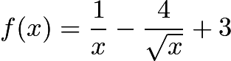 where 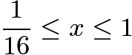, find the range of $f(x)$.  
  
$ \textbf{(A) }-2\le f(x)\le 4 \qquad\textbf{(B) }-1\le f(x)\le 3\qquad\textbf{(C) }0\le f(x)\le 3\qquad\textbf{(D) }-1\le f(x)\le 4\qquad\textbf{(E) }\text{None of the above} $$ \textbf{(A) }-2\le f(x)\le 4 \qquad\textbf{(B) }-1\le f(x)\le 3\qquad\textbf{(C) }0\le f(x)\le 3\qquad\textbf{(D) }-1\le f(x)\le 4\qquad\textbf{(E) }\text{None of the above} $

**Short Answer**

**June 3rd**

**11**

Suppose that $x$ is real number such that 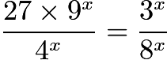. Find the value of $2^{-(1+\log_23)x}$

**12**

Evaluate $50(\cos 39^{\circ}\cos21^{\circ}+\cos129^{\circ}\cos69^{\circ})$

**13**

Suppose $a$ and $b$ are real numbers such that the polynomial $x^3+ax^2+bx+15$ has a factor of $x^2-2$. Find the value of $a^2b^2$.

**14**

In triangle $\triangle ABC$, $D$ lies between $A$ and $C$ and $AC=3AD$, $E$ lies between $B$ and $C$ and $BC=4EC$.  
$B,G,F,D$ in that order, are on a straight line and $BD=5GF=5FD$. Suppose the area of $\triangle ABC$ is $900$, find the area of the triangle $\triangle EFG$.

**15**

Let $x,y$ be real numbers such that $y=|x-1|$. What is the smallest value of $(x-1)^2+(y-2)^2$?

**16**

Evaluate the sum 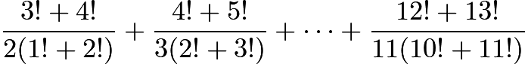

**17**

Let $n$ be a positive integer such that $12n^2+12n+11$ is a $4$-digit number with all $4$ digits equal. Determine the value of $n$.

**18**

Given that in the expansion of $(2+3x)^n$, the coefficients of $x^3$ and $x^4$ are in the ratio $8:15$. Find the value of $n$.

**19**

In a triangle $\triangle ABC$ it is given that $(\sin A+\sin B):(\sin B+\sin C):(\sin C+\sin A)=9:10:11$.  
Find the value of $480\cos A$

**20**

Let 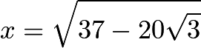. Find the value of 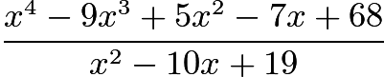

**21**

Let $n$ be an integer, and let $\triangle ABC$ be a right-angles triangle with right angle at $C$. It is given that $\sin A$ and $\sin B$ are the roots of the quadratic equation\[(5n+8)x^2-(7n-20)x+120=0.\]Find the value of $n$

**22**

Let $S_1$ and $S_2$ be sets of points on the coordinate plane $\mathbb{R}^2$ defined as follows  
\[S_1={(x,y)\in \mathbb{R}^2:|x+|x||+|y+|y||\le 2}\]  
\[S_2={(x,y)\in \mathbb{R}^2:|x-|x||+|y-|y||\le 2}\]  
Find the area of the intersection of $S_1$ and $S_2$

**23**

Let $n$ be a positive integer, and let 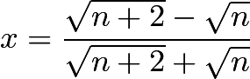 and 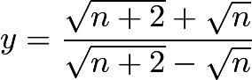.  
  
It is given that $14x^2+26xy+14y^2=2014$. Find the value of $n$.

**24**

Find the number of integers $x$ which satisfy the equation $(x^2-5x+5)^{x+5}=1$.

**25**

Find the number of ordered pairs of integers (p,q) satisfying the equation $p^2-q^2+p+q=2014$.

**26**

Suppose that $x$ is measured in radians. Find the maximum value of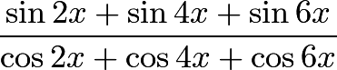for 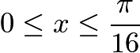

**27**

Determine the number of ways of colouring a $10\times 10$ square board using two colours black and white such that each $2\times 2$ subsquare contains 2 black squares and 2 white squares.

**28**

In the isoceles triangle $ABC$ with $AB=AC$, $D$ and $E$ are points on $AB$ and $AC$ respectively such that $AD=CE$ and $DE=BC$. Suppose $\angle AED=18^{\circ}$. Find the size of $\angle BDE$ in degrees.

**29**

Find the number of ordered triples of real numbers $(x,y,z)$ that satisfy the following systems of equations:  
$x^2=4y-4,y^2=4z-4,z^2=4x-4$

**30**

Let $X={1,2,3,4,5,6,7,8,9,10}$ and $A={1,2,3,4}$. Find the number of $4$-element subsets $Y$ of $X$ such that $10\in Y$ and the intersection of $Y$ and $A$ is not empty.

**31**

Find the number of ways that $7$ different guests can be seated at a round table with exactly 10 seats, without removing any empty seats. Here two seatings are considered to be the same if they can be obtained from each other by a rotation.

**32**

Determine the maximum value of 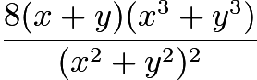 for all $(x,y)\neq (0,0)$

**33**

Find the value of $2(\sin2^{\circ}\tan1^{\circ}+\sin4^{\circ}\tan1^{\circ}+\cdots+\sin178^{\circ}\tan 1^{\circ})$

**34**

Let $x_1,x_2,\dots,x_{100}$ be real numbers such that $|x_1|=63$ and $|x_{n+1}|=|x_n+1|$ for $n=1,2\dots,99$.  
Find the largest possible value of $(-x_1-x_2-\cdots-x_{100})$.

**35**

Two circles intersect at the points $C$ and $D$. The straight lines $CD$ and $BYXA$ intersect at the point $Z$. Moreever, the straight line $WB$ is tangent to both of the circles. Suppose $ZX=ZY$ and $AB\cdot AX=100$. Find the value of $BW$.

**Second Round**

**June 28th**

**1**

In the triangle $ABC$, the excircle opposite to the vertex $A$ with centre $I$ touches the side BC at D. (The circle also touches the sides of $AB$, $AC$ extended.) Let $M$ be the midpoint of $BC$ and $N$ the midpoint of $AD$. Prove that $I,M,N$ are collinear.

**2**

Find, with justification, all positive real numbers $a,b,c$ satisfying the system of equations:  
  
\[a\sqrt{b}=a+c,b\sqrt{c}=b+a,c\sqrt{a}=c+b.\]

**3**

Some blue and red circular disks of identical size are packed together to form a triangle. The top level has one disk and each level has 1 more disk than the level above it. Each disk not at the bottom level touches two disks below it and its colour is blue if these two disks are of the same colour. Otherwise its colour is red.  
  
Suppose the bottom level has 2048 disks of which 2014 are red. What is the colour of the disk at the top?

**4**

For each positive integer $n$ let\[x_n=p_1+\cdots+p_n\]where $p_1,\ldots,p_n$ are the first $n$ primes. Prove that for each positive integer $n$, there is an integer $k_n$ such that $x_n<k_n^2<x_{n+1}$

**5**

Alice and Bob play a number game. Starting with a positive integer $n$ they take turns changing the number with Alice going first. Each player may change the current number $k$ to either $k-1$ or $\lceil k/2\rceil$. The person who changes $1$ to $0$ wins. Determine all $n$ such that Alice has a winning strategy.

SMO 2014 (Senior Section) Answers  
  
1. D  
2. A  
3. C  
4. D  
5. A  
6. C  
7. D  
8. B  
9. D  
10. B  
11. 27  
12. 25  
13. 225  
14. 90  
15. 2  
16. 95  
17. 21  
18. 8  
19. 270  
20. 7  
21. 66  
22. 3  
23. 5  
24. 4  
25. 16  
26. 1  
27. 2046  
28. 42  
29. 1  
30. 74  
31. 60480  
32. 9  
33. 2  
34. 2034  
35. 10